NAME: Pranay Reddy ID NO: 2520080061

PRACTICAL WEEK 7

Task 1: Write a program that prints the addresses Of code, global, static, heap, and stack variables. Analyze the Linux process address space layout and explain each memory segment.
- Create a file
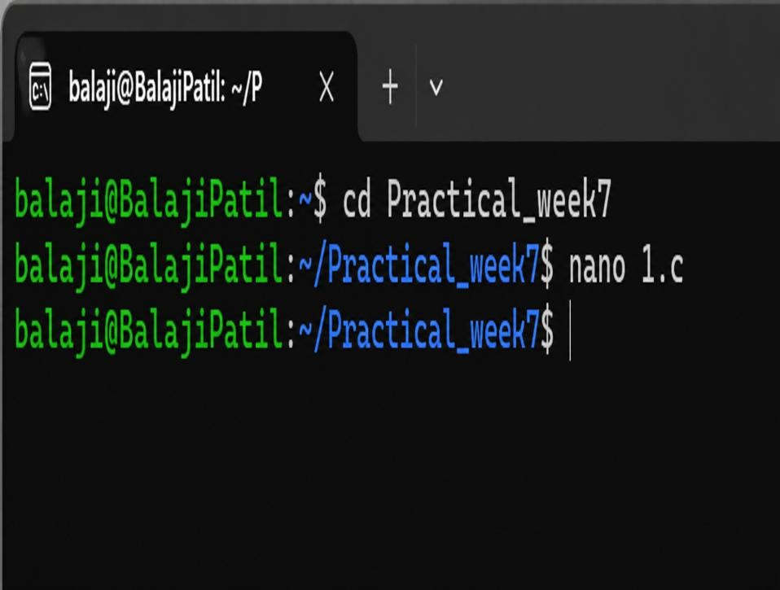

Then press enter to open command
- write a code
- 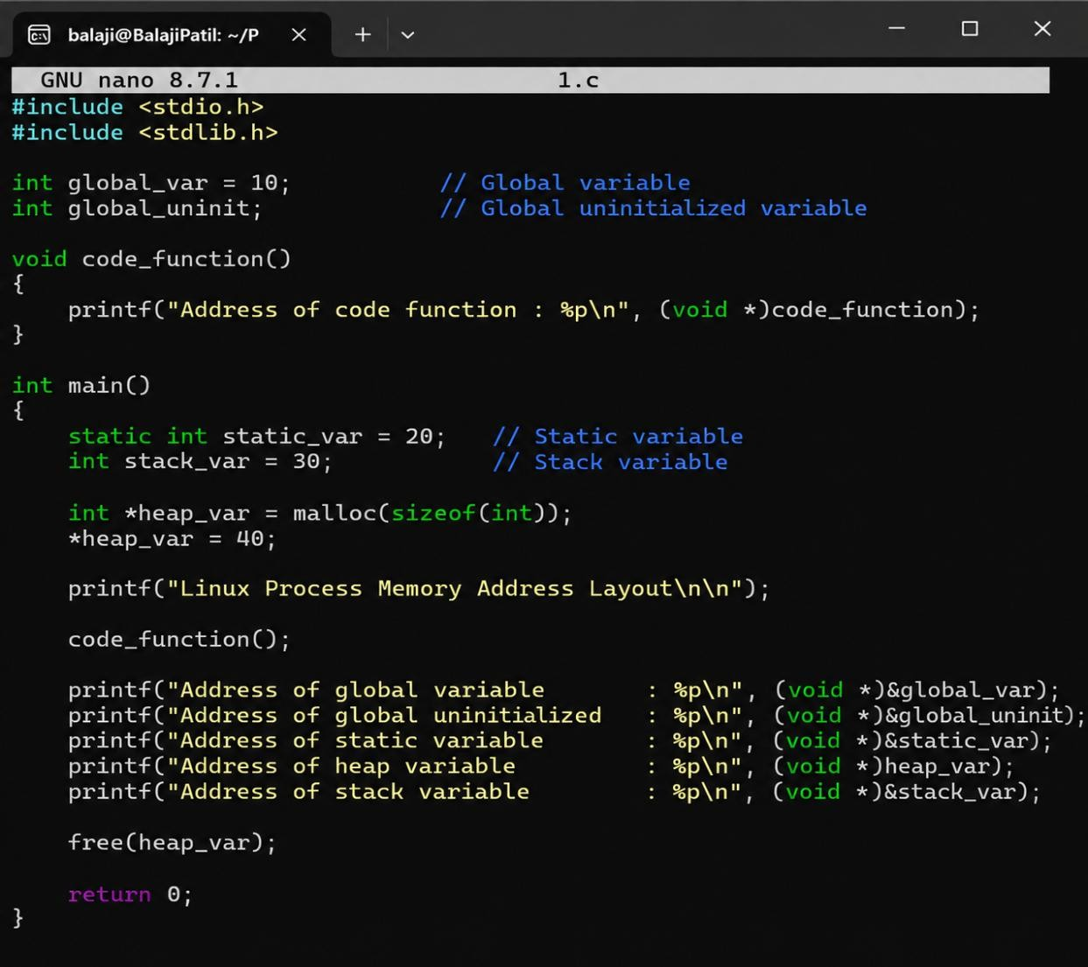
  - To save press control O
  - To come back to shell press control X
  - Then DO compilation
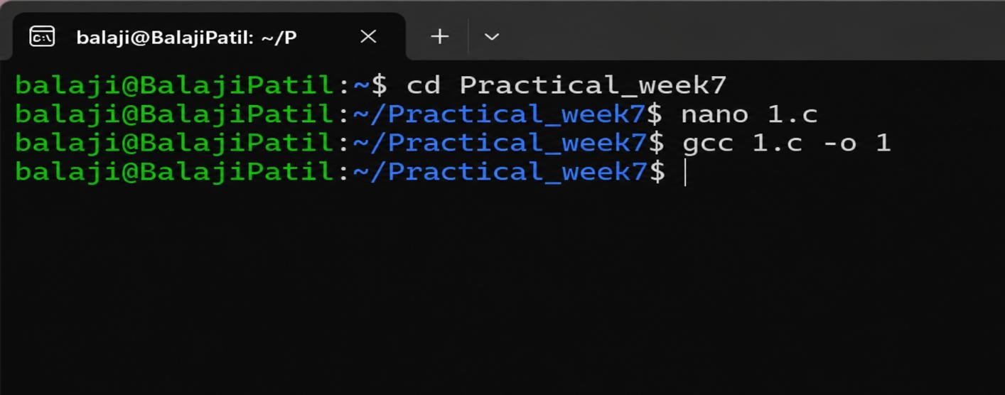

OUTPUT:

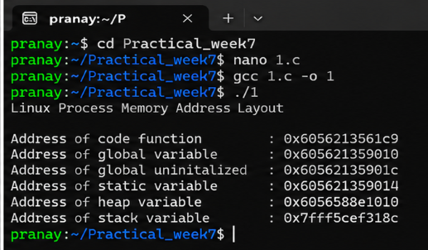

Task-2: Make use of the /proc//maps file and memory analysis tools to study the memory organization of a running process. Prepare a report explaining virtual memory mappings.
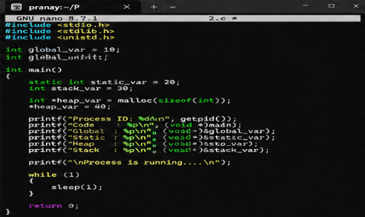
OUTPUT:
